**System Summary**

**High-level description of the Eternal Flight System**

The Eternal Flight System (EFS) is a prototype Battery Swapping System (BSS) designed to enable near-perpetual flight for Unmanned Aerial Vehicles (UAVs) in various operational scenarios. The system was designed for the specific use case of nuclear decommissioning; therefore, it is expected UAVs which use the EFS which undertake visual inspection, maintenance, characterisation, and monitoring of facilities. The EFSs purpose is to facilitate autonomous battery hot swapping (UAV remains powered during battery swapping), allowing a UAVs battery to be quickly replaced with a fully charged one, thereby extending their flight duration without the need for manual intervention.

The objectives of the Eternal Flight System can be summarized as follows:

1. Autonomous Battery Hot Swapping: The primary objective is for the EFS to autonomously swap UAV batteries quicker than the state of the art (8 seconds). A battery hot swapping time of 3.0 seconds was achieved.
2. Near-Perpetual Flight: The system aims to provide near-perpetual flight capabilities for UAVs by enabling rapid battery swaps and charging UAV batteries while stored. This allows UAVs to operate continuously without significant downtime for manual battery recharging or replacement.
3. Enhanced UAV Flight Control: The software team focused on developing and refining UAV flight control capabilities. This includes developing a localization framework using existing technologies, such as VICON implementation, to enable precise positioning of the UAVs. Additionally, an AR tag-based vision system is integrated into the flight controller, enabling UAV landing in previously unseen environments.
4. Efficient and Robust Battery Swapping: The system employs a novel solution for battery swapping, utilizing a single motor for actuation. This design ensures energy efficiency, speed, and robustness with fewer moving parts compared to other systems. Auxiliary components, such as the module, cage, and spring plate, are designed and implemented to establish a physical connection between the UAV and the BSS.
5. Battery Management and Monitoring: A Battery Management System (BMS) is developed to monitor the State of Charge (SoC) and voltage of the UAV batteries. The BMS distributes this data to the rest of the system using the MQTT protocol. The SoC data of the batteries is used to determine when an operating UAV battery requires changing and which battery on the EFS will replace the depleted batter. Power connections between the UAV and the BSS are implemented and integrated with detachable UAV components.
6. Communication: A communication network is established to facilitate sequential operation between the BSS base station, UAV onboard computer, BMS chips, and motor.

The Eternal Flight System incorporates several key features to enhance its functionality and reliability:

1. Single Motor Actuation: The system utilizes a single motor for battery swapping, which increases reliability by reducing the number of moving parts. This design choice ensures energy efficiency, speed, and robustness during the swapping process.
2. IR Sensor Alignment: An infrared (IR) sensor is employed to align the motor accurately. The IR sensor helps in precisely positioning the battery module for seamless attachment and detachment, ensuring a secure connection during the swapping operation.
3. Control Algorithm for Swaps: The system incorporates a control algorithm specifically designed to facilitate battery swaps. This algorithm orchestrates the movements of the motor, ensuring smooth and efficient battery replacement within the desired timeframe.
4. Search Algorithm for Realignment: In cases where the battery module is misaligned, a search algorithm is implemented to identify and correct any discrepancies. This realignment process ensures proper positioning of the battery module before initiating the battery swap.
5. AR Tag Alignment for UAV Landing: To enable UAV landing on the Eternal Flight System, an AR tag-based vision system is utilized. The AR tag allows the UAV to align itself accurately with the BSS platform, ensuring a safe and precise landing.
6. Bespoke Charger and BMS Board: The system incorporates a custom-designed charger and Battery Management System (BMS) board. The bespoke charger facilitates efficient and effective charging of the UAV batteries, ensuring optimal performance. The BMS board monitors the battery's State of Charge (SoC), voltage, and other parameters, enhancing battery management and overall system safety.
7. Lightweight Design with Built-in Gear: The Eternal Flight System is designed to be lightweight. The gear mechanism required for rotating the battery storage unit during the swapping process is integrated into the system, optimizing space and reducing complexity.
8. Versatile Battery Module: The system accommodates various types of UAV batteries through a versatile battery module. This flexibility allows different UAV models with different battery specifications to utilize the BSS, ensuring compatibility and adaptability across a range of UAV platforms.
9. Compatibility with AGV (Husky ClearPath): The Eternal Flight System can be mounted on an Autonomous Ground Vehicle (AGV) such as the Husky ClearPath. This integration allows for increased mobility and deployment options, enabling the BSS to be utilized in diverse environments and scenarios.

**Overall architecture of the system**

The overall architecture of the Eternal Flight System consists of several major components that work together to enable autonomous flight, battery swapping, and power management. These components interact with each other through various interfaces to ensure the smooth operation of the system. Here is an overview of the major components and their interactions:

1. Unmanned Aerial Vehicle (UAV): The UAV serves as the flying platform and is equipped with sensors, a flight controller, and an onboard computer. It communicates with the BSS and the power management system to exchange data and receive commands.
2. Battery Swapping System (BSS): The BSS is responsible for the quick and automated swapping of UAV batteries. It consists of the battery module, cage, spring plate, and a single motor for actuation. The motor is controlled by a motor control algorithm, which allows for precise battery swapping. An IR sensor is used to align the motor during the swapping process.
3. Power Management System: This system includes the Power Rail, Battery Management System (BMS), and the bespoke charger. The Power Rail provides the necessary power to the BSS motor and other components. The BMS monitors the state of charge (SoC) and voltage of the batteries and communicates this data to the rest of the system. The bespoke charger is responsible for recharging the batteries.
4. Communication Network: A wireless communication network is established between the BSS, UAV onboard computer, BMS chips, and the motor. This network allows for data transfer and coordination between different components of the system. It enables sequential operation and synchronization of the processes involved in autonomous landing, battery swapping, and take-off.

Overall, the architecture of the system enables seamless integration and interaction between the UAV, BSS, and power management system. The communication network and interfaces facilitate data exchange and coordination, while the GUI provides a user-friendly interface for system control and monitoring.

**Diagrams or schematics to illustrate the system architecture and component relationships**

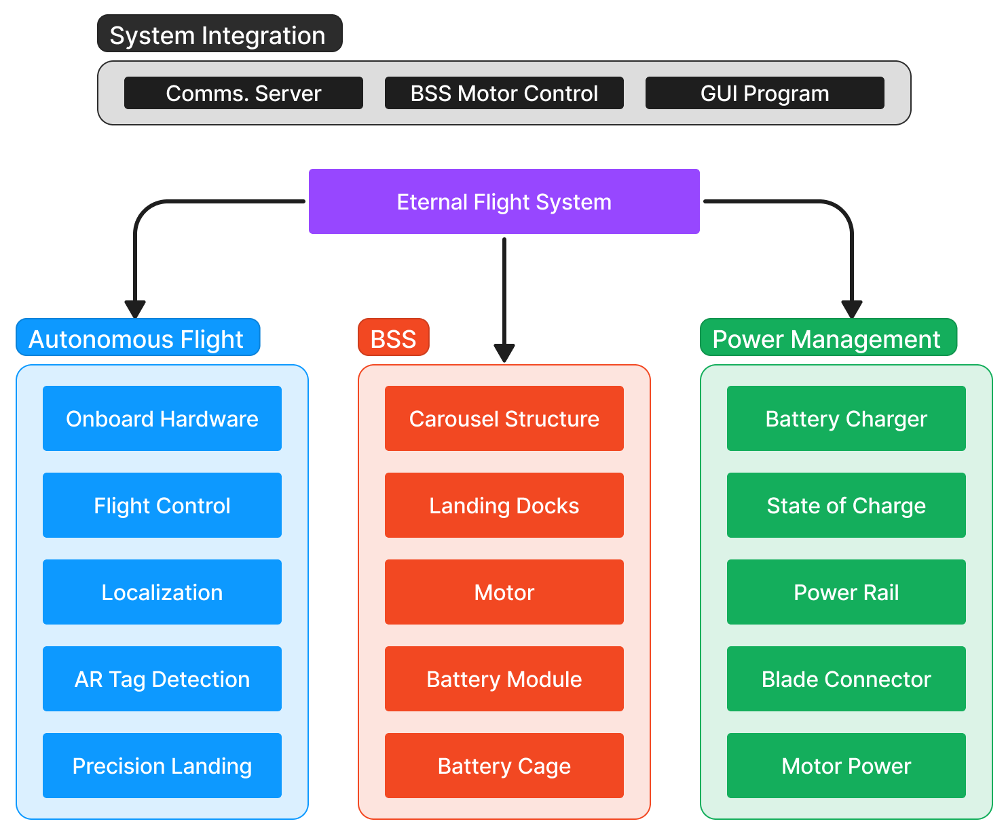

**Figure 1.** BSS system design.

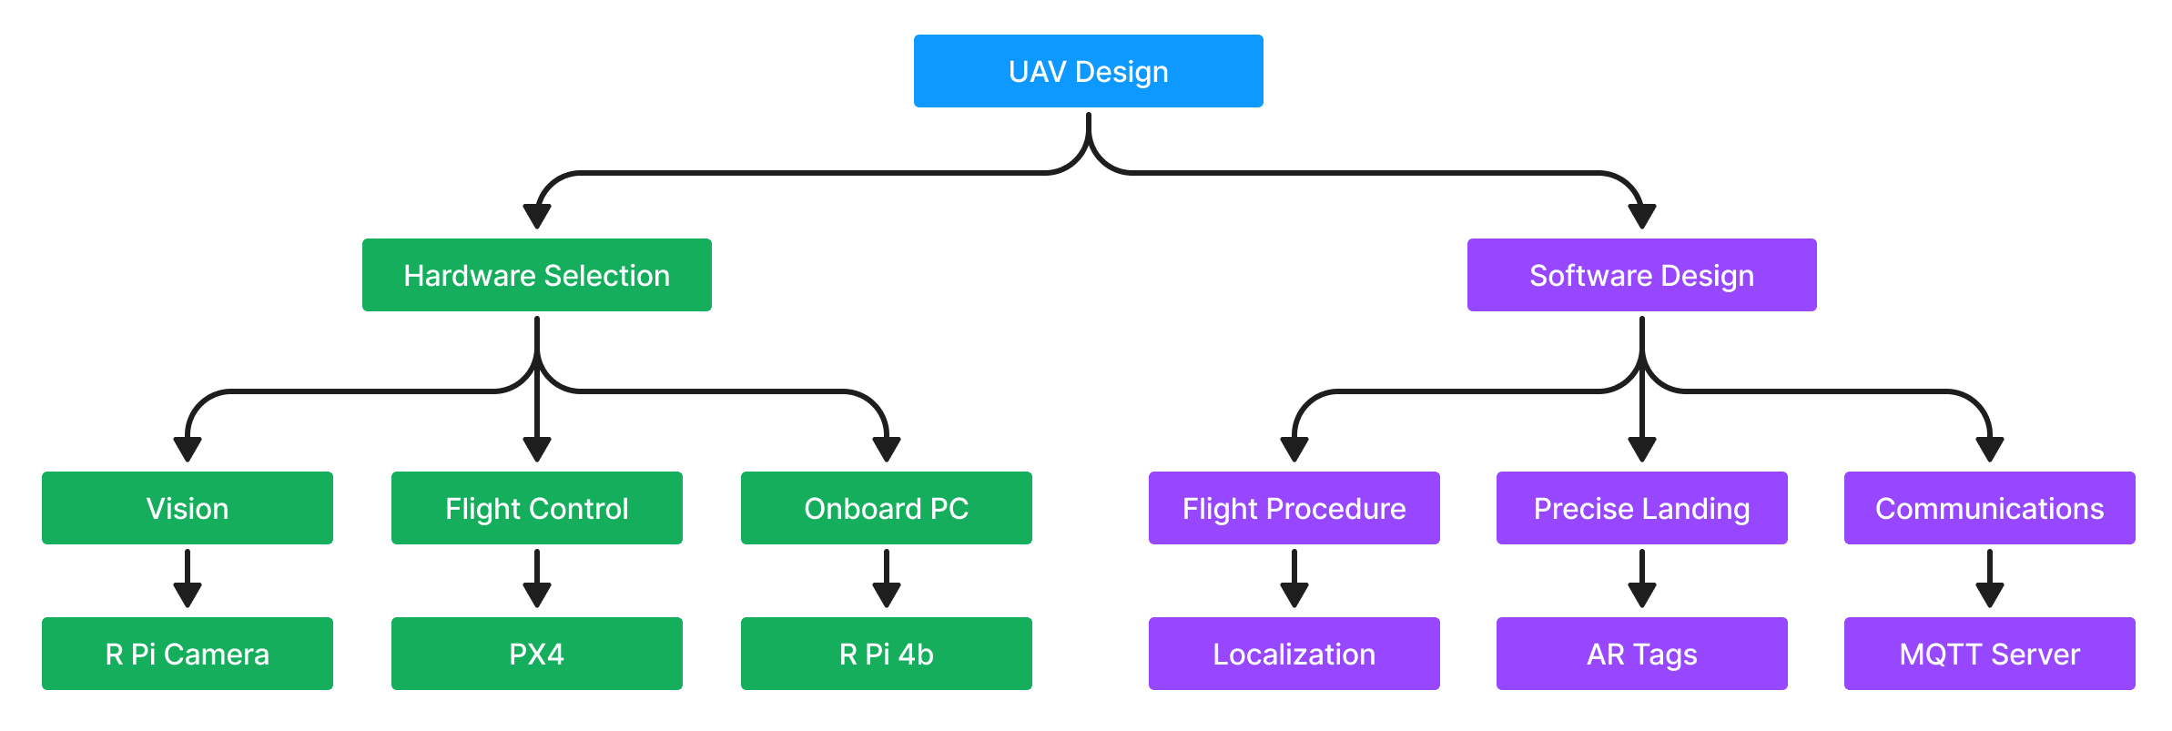

**Figure 3.** UAV hardware selection and software design.

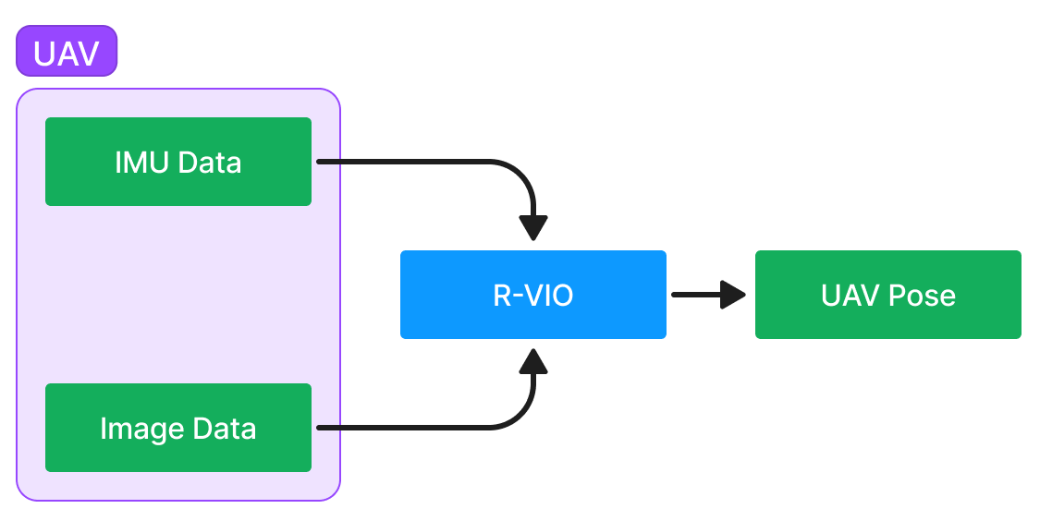

**Figure 2.** R-VIO localisation process.

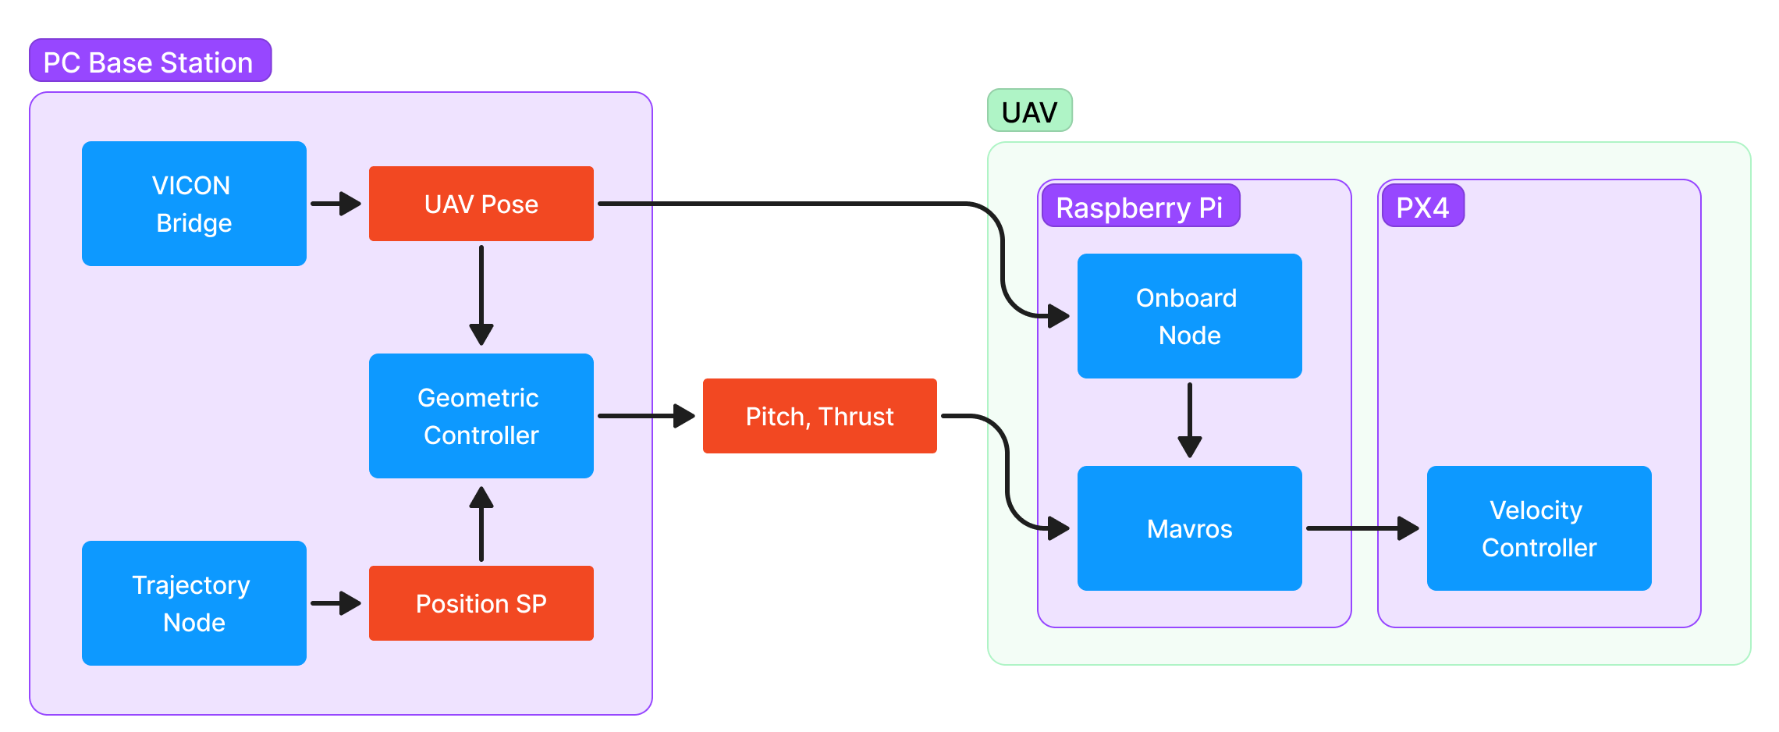

**Figure 4.** Process division for autonomous flight with VICON.

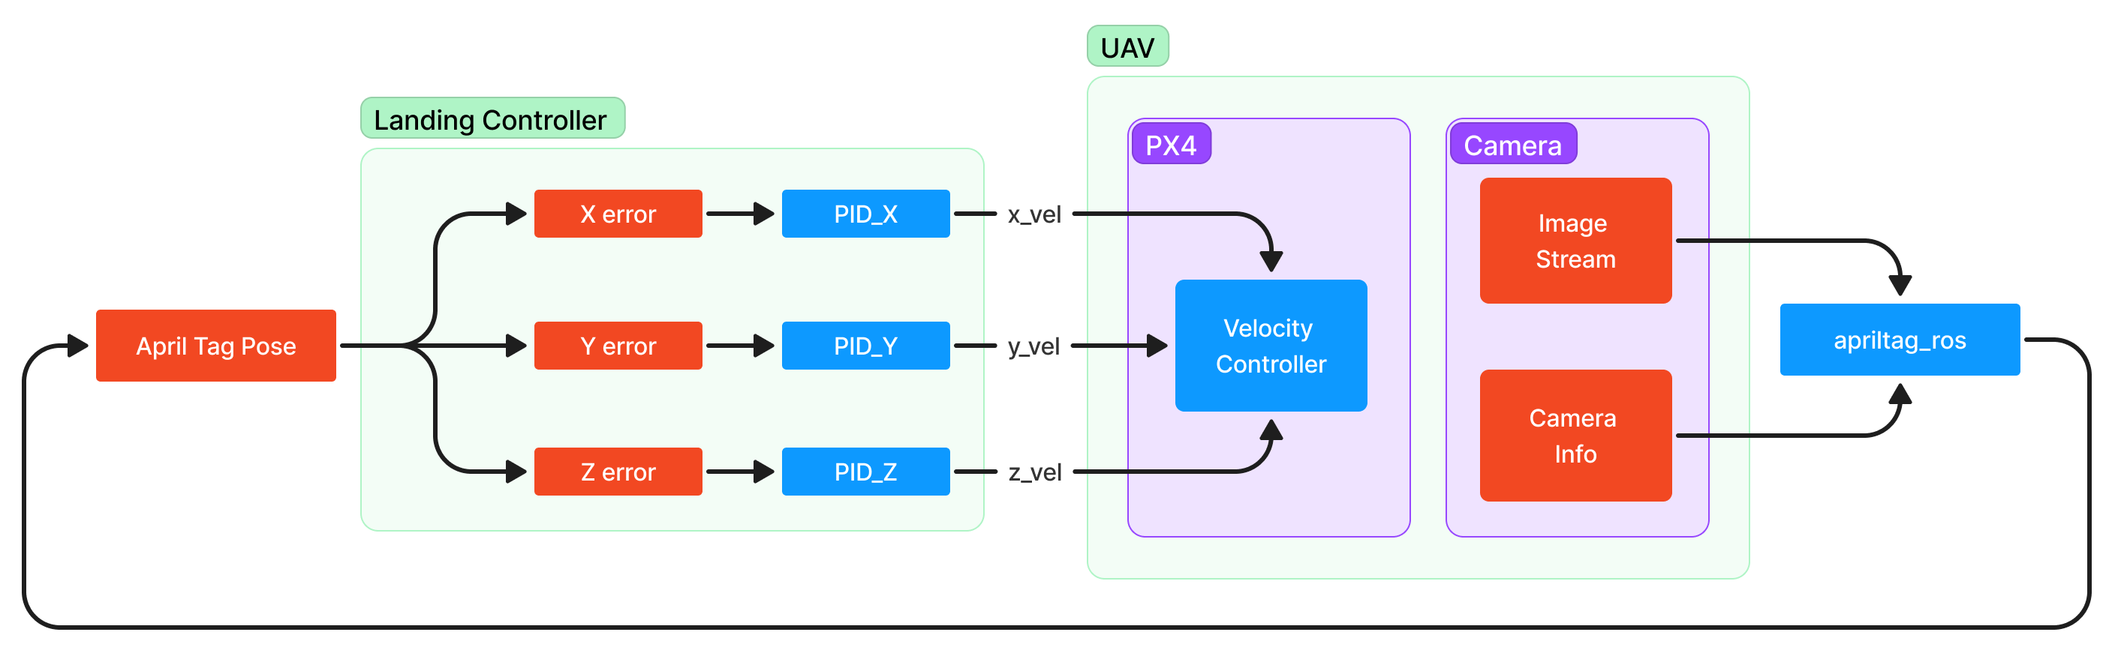

**Figure 5.** UAV landing process via April Tag detection.

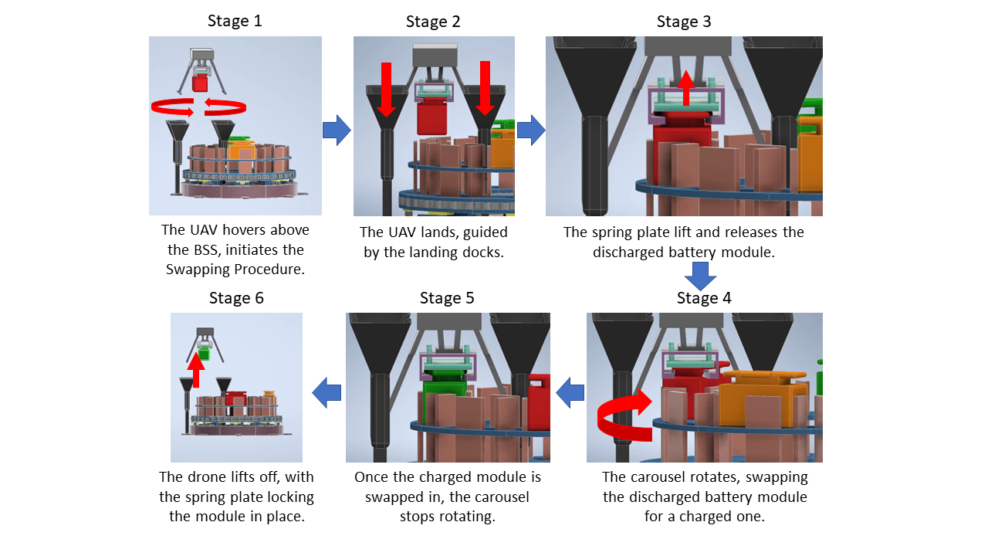

**Figure 6.** Battery swapping process.

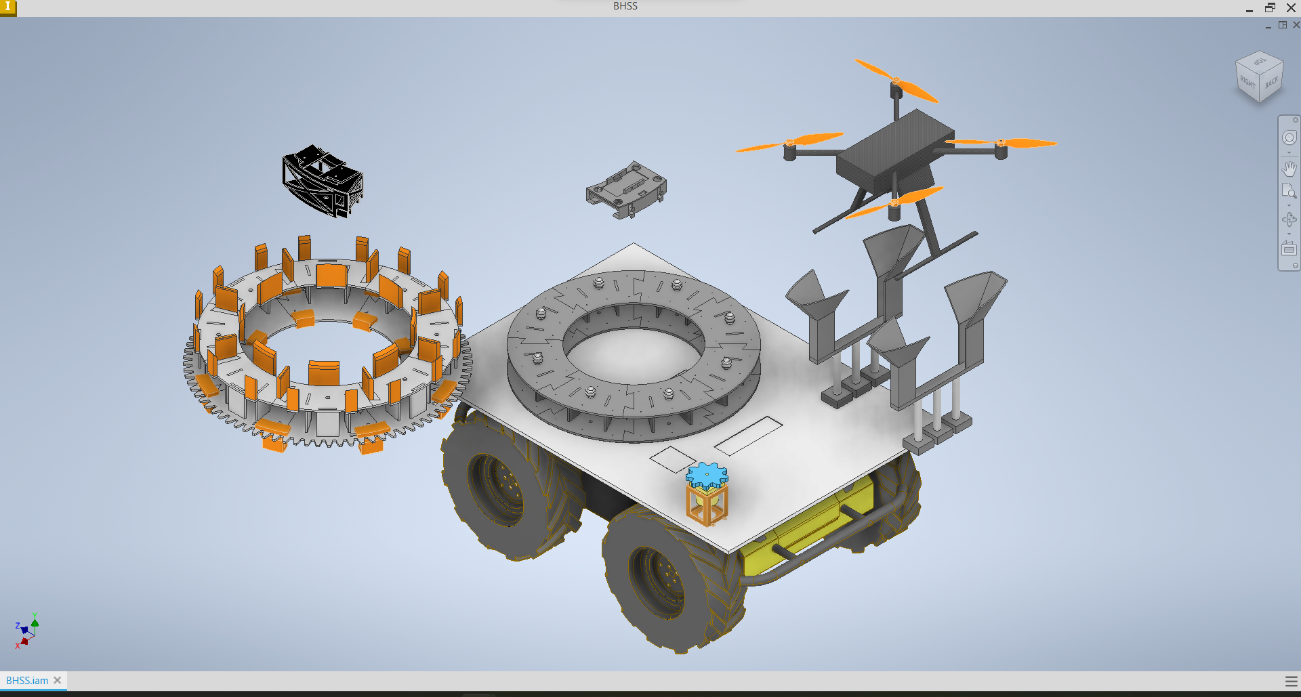

Battery Cage

Battery Module

UAV

Landing Docks

Motor

Rotating Carousel

Non-rotating Carousel

**Figure 8.** BSS component breakdown.

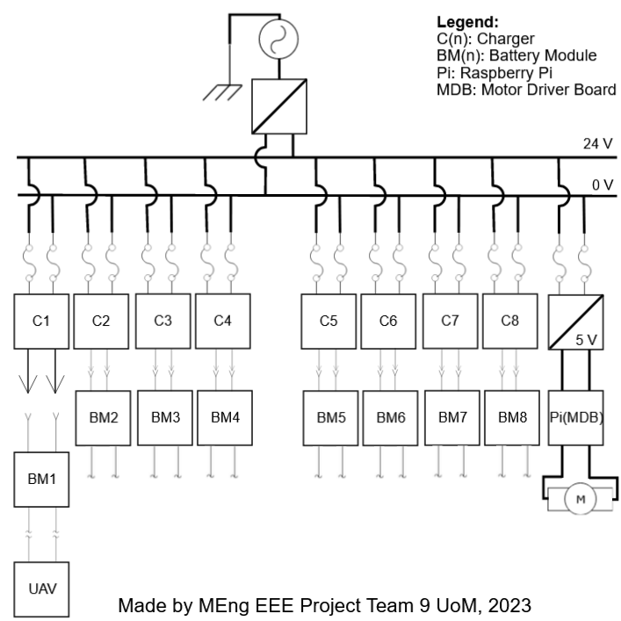

**Figure 7.** Power rail schematic.

PCB Schematics can be found in file 1.2 on the [GitHub](https://github.com/will700/EFS_2023/tree/main/1.%20System%20Summary).

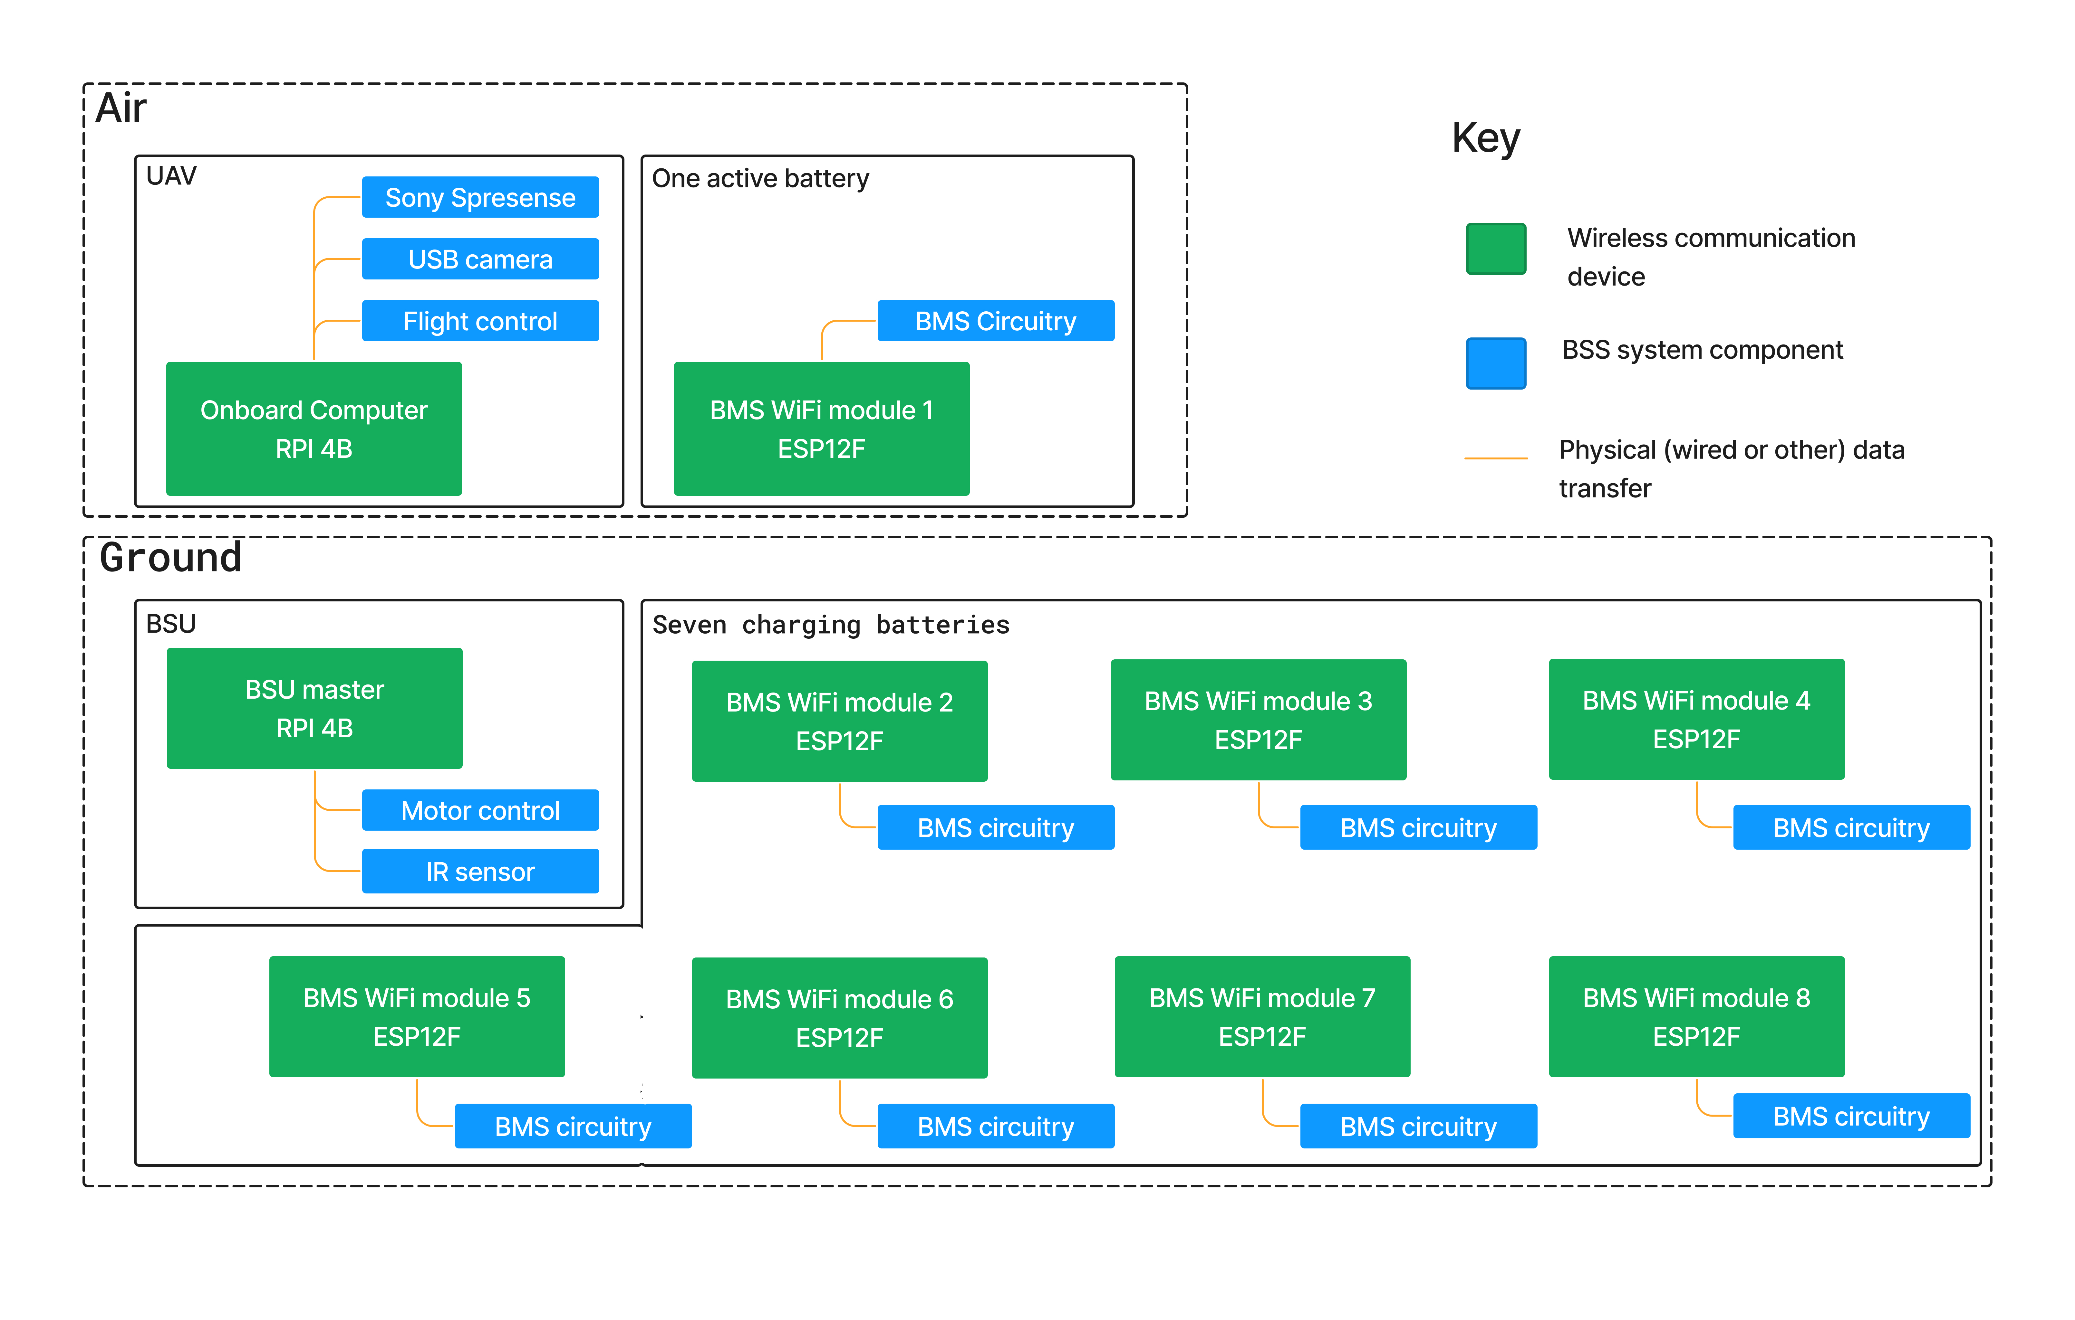

**Figure 9.** Communication overview.